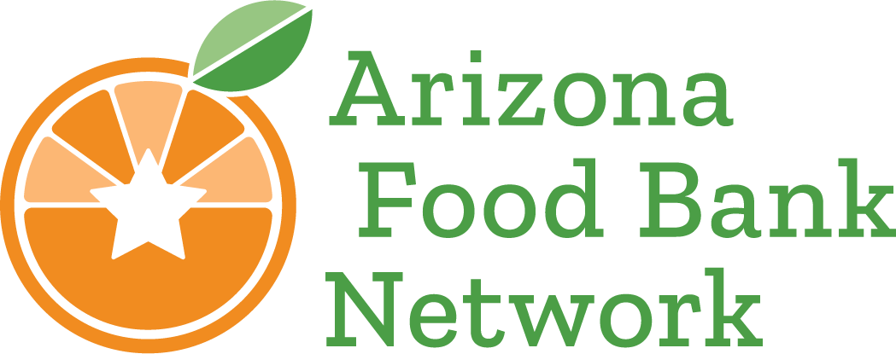

**LGBTQIA2S+ Food Insecurity Survey**

**Social Media Kit**

Greetings,

Arizona Food Bank Network is conducting vital research on food security among the LGBTQIA2S+ community in Arizona, and we need your help to reach a wide audience that captures the full extent of the issue. We know that food insecurity disproportionately affects LGBTQIA2S+ individuals, with national studies showing that this population is nearly twice as likely to experience food insecurity compared to their non-LGBTQ+ peers *(*[*Williams Institute, 2016*](https://williamsinstitute.law.ucla.edu/publications/lgbt-food-insecurity-snap/)*)*. Transgender individuals and people of color within the community especially experience this issue. *(*[*Feeding America, 2020*](https://www.accfb.org/hunger-is-a-queer-issue/)*)*.

Despite these alarming statistics, research on food insecurity within Arizona's LGBTQIA2S+ community remains limited. That is why AzFBN is conducting a survey and holding focus groups throughout Arizona to gather crucial data on the unique challenges faced by this community. This qualitative and quantitative information will be instrumental in creating targeted solutions to enhance food access and support for this vulnerable population. The survey will be open now through December31, 2024. In March 2025, a comprehensive report will detail the study's findings.

With great data, we can do great things! We have made it easy for you to share the survey using our provided graphics, captions, and hashtags. You can help us reach a wider audience of Arizonans and gain a comprehensive understanding of the LGBTQIA2S+ community’s needs by simply spreading the word about this project. In turn, the data we build will enable your organization to better understand and address the state of food security for the LGBTQIA2S+ folks in your community. Let's #EndHungerWithPride!

Warmly,

Isabel Loga

(602)363-2419

[Isabel.loga@azfoodbanks.org](mailto:Isabel.loga@azfoodbanks.org)

Azfoodbanks.org

**Getting Started**

1. **Download Graphic-** We have graphic options for Instagram, Facebook, and Twitter available to download within this Zip File.
2. **Pick a caption and add hashtags-** Below are some caption ideas our team has come up with for your convenient sharing. We have also included two hashtags that we are using to track this project, please add both hashtags to the end of your post’s caption.
   1. "We need your help to uncover the reality of food insecurity in the LGBTQ+ community in Arizona. Take our survey and be entered to win a $20 gift card. Let's make a difference together! Find it here: bit.ly/LGBTQIA2S-Survey”
   2. "AZ Food Bank Network is conducting vital research on food insecurity among LGBTQ+ individuals in Arizona. Participate in our survey and get a chance to win a $20 visa gift card. Share your story at bit.ly/LGBTQIA2S-Survey”
   3. "Be part of groundbreaking research on food insecurity in the LGBTQ+ community in AZ! Take our survey and enter to win a $20 gift card. Find it here: bit.ly/LGBTQIA2S-Survey”
   4. "Your voice matters! Help us understand and tackle food insecurity among the LGBTQ+ community in Arizona. Complete our survey and you have a chance to win a $20 gift card! Take the survey here: bit.ly/LGBTQIA2S-Survey”
   5. "Join our survey on food insecurity in the LGBTQ+ community in AZ and enter to win a $20 gift card! Complete the survey here: bit.ly/LGBTQIA2S-Survey”
   6. "Help us tackle food insecurity in the LGBTQ+ community in Arizona by taking our survey. Provide your input for a chance to win a $20 gift card! Complete the survey today: bit.ly/LGBTQIA2S-Survey”
   7. **Hashtags:**
      1. #EndingHungerWithPride
      2. #HungerFreeAZ
3. **Next steps**
   1. **Encourage Participation:** Urge your followers and community members to take part in the survey, emphasizing the importance of their input.
   2. **Raise Awareness:** Highlight the impact of food insecurity on LGBTQIA2S+ individuals and the need for targeted solutions.

**Happy Posting!**